
NOTE: This is an official document by Indexademics. Unless otherwise stated, this document may not be accredited to individuals or groups other than the club IDX, nor should this document be distributed, sold, or modified for personal use in any way.
IDX G9 MATH S+ STUDY GUIDE ISSUE 8
By Aiden and Julie, Edited by Indy

Coordinate Geometry (Points, Lines, and Circles)

Content:
- points and lines
- slopes of lines
- finding equations of lines
- circles in the coordinate plane
- proofs using coordinate geometry
- practice questions

1. Coordinate Geometry Basics

Key Concepts
- Rectangular (Cartesian) Coordinate System:
  - x-axis: Horizontal number line.
  - y-axis: Vertical number line, perpendicular to the x-axis.
  - Origin: Point of intersection of the x- and y-axes, (0,0).
  - Quadrants: Four regions created by the axes (1,2,3,4).
- Ordered Pairs: Represent points as (x, y), where:
  - Abscissa (x-coordinate): Distance from the y-axis.
  - Ordinate (y-coordinate): Distance from the x-axis.

2. Linear Equations

Key Definitions
- A set (S) of ordered pairs (x, y) can be represented by a point in the plane.
- x-intercept: Where the graph intersects the x-axis (y = 0).
- y-intercept: Where the graph intersects the y-axis (x = 0).

Forms of Linear Equations
- General Form: (Ax + By = C)
- Slope-Intercept Form: (y = mx + k), where:
  - (m): Slope.
  - (k): y-intercept.
- Point-Slope Form: (Y - y1 = m (X - x1)), where (x1, y1) is a point on the line.
- Intercept Form: (x/a+ y/b = 1), where (a) is the x-intercept and (b) is the y-intercept.

Finding Intercepts
- Example: For (2x + 3y = 15):
  - y-intercept: Set (x = 0): (3y = 15 y = 5). So, y-intercept is (0, 5).
  - x-intercept: Set (y = 0): (2x = 15 x = 7.5). So, x-intercept is (7.5, 0).

3. Distance and Midpoint Formulas

Formulas
- Distance Formula: For points (A (x1, y1)) and (B (x2, y2)): [ AB =$\sqrt{{(x2-x1)}^{2}+{(y2-y1)}^{2}}$.]
- Midpoint Formula: For the midpoint (M) of segment (AB): [ M = (x1+x2)/2, (y1+y2)/2]

5. Slopes of Lines

Slope Formula
- For points (x1, y1) and (x2, y2): [ m = y2-y1/x2-x1]
- Horizontal lines: Slope (m = 0).
- Vertical lines: Slope is undefined.
- Positive slope: Line rises (as (x) increases, (y) increases).
- Negative slope: Line falls (as (x) increases, (y) decreases).

Parallel and Perpendicular Lines
- Parallel Lines: Same slope ((m1 = m2)).
- Perpendicular Lines: Slopes are negative reciprocals (m1* m2 = -1).

6. Circles in the Coordinate Plane

Standard Equation of a Circle
- Center ((h, k)), radius (r): [${(x-h)}^{2}+{(x-k)}^{2}=r^{2}$]

Tangent to a Circle
- A line is tangent to a circle if it intersects at exactly one point.

7. Proofs Using Coordinate Geometry

Midsegment Theorem (Trapezoid)
- The midsegment of a trapezoid is parallel to the bases and its length is the average of the lengths of the bases.
8.
Find an equation in the most convenient form of the line described.
- The line with x-intercept −3 and y-intercept 8.
- The line with x-intercept −2 and through (3,7).
- The line pass through (8,5) and perpendicular to 𝑦 = 4.
- The line pass through (9,2) and origin.

- A quadrilateral with vertices(−4,4), (−6,0), (−4, −4), (−2,0). Name the type of quadrilateral and find its area. (No proof is required.)

- 𝐴𝐵𝐶𝐷 is a square with vertices 𝐴(0,0) and 𝐵(5,3). Find the coordinates of the point 𝐶 and 𝐷.

- △𝐴𝐵𝐶 has vertices 𝐴(−2,−1), 𝐵(0,7),and 𝐶(8,3).
  - Find an equation of the median from 𝐴.
  - Find an equation of the altitude from 𝐶.
  - Find the circumcenter 𝑄 of △ABC

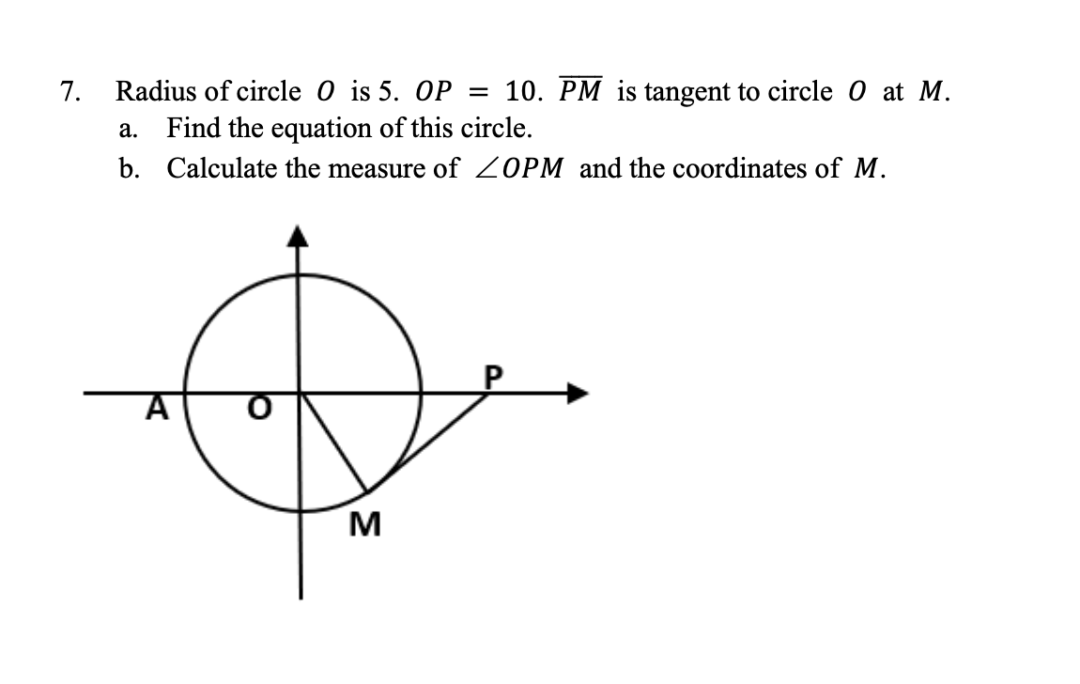
Answer key:
- x/-3 + y/8 =1
- y-7=7/5 (x-3)
- x=8
- y=2x/9
- Rhombus; 16
- D(-3,5) C(5-3,5+3) or D(3,-5) C(8,2)
- 1) y=x+1
2) y=-x/4+7
3) (23/9, 19/9)
7. a. x平方+y平方=25
b. 30 degrees; M(2.5,-2.5更号3)

